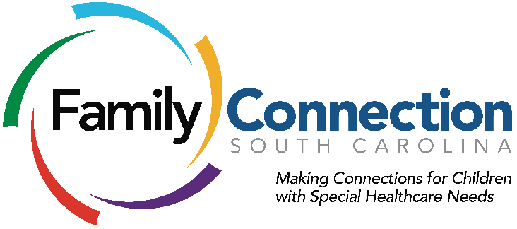

For More Information Contact:
Amanda Ball
Communications Manager
Family Connection of South Carolina
ABall@FamilyConnectionSC.org
803.252.0914

For Immediate Release

FAMILY CONNECTION OF SOUTH CAROLINA RECEIVES $1.4 MILLION IN FEDERAL FUNDING

(August 6, 2015) COLUMBIA, S.C. - Family Connection of South Carolina has been awarded the 2015 Office of Special Education and Information for Parents and Children of Disabilities - Parent Training and Information Centers (PTI) grant issued by the US Department of Education and Rehabilitative Services.

Upon receipt of the funding, Family Connection will be tasked to provide information and training for parents and individuals, birth to 26, with disabilities and healthcare needs in South Carolina. Family Connection will help parents navigate systems of early intervention, general and special education, and postsecondary education. Individuals served will better understand their role as self-advocates and their rights and responsibilities in order to develop increased inclusion in both school, postsecondary settings, and future employment settings.

Since 1989, Family Connection’s mission has been to strengthen and encourage families of children with special healthcare needs through parent support. As South Carolina’s Family-to-Family Health Information Center, with the addition of the PTI grant, the organization’s 600 trained parents will now be able to educate, inspire and empower parents and individuals with disabilities about their rights and responsibilities in the school system.

“We received this grant because of the support and collaboration of our community partners, state agencies and parents,” said Amy Nienhuis Holbert, executive director of Family Connection. “With the PTI grant, Family Connection will be able to ensure that individuals with disabilities have access to the appropriate services to achieve their academic and personal goals. South Carolina is one step closer to streamlining all of the information for families and individuals with special needs.”

As the new PTI, Family Connection will utilize their partnerships with The South Carolina Department of Special Education Services, Protection and Advocacy of South Carolina, Able South Carolina, South Carolina FirstSteps/BabyNet, the South Carolina Developmental Disabilities Council, the Arnold School of Public Health at the University of South Carolina, and
the Center for Disability Resources at the University of South Carolina School of Medicine,
to implement these services and ensure continuous quality improvement efforts. Family Connection is thrilled to accept this new set of responsibilities and help spread the word to families seeking this information and related resources.

About the Organization
Family Connection of South Carolina is a nonprofit organization that provides support, information and resources for families, professionals and individuals, of all ages, with special healthcare needs, disabilities, or chronic illness. The organization was founded in 1989 by a group of South Carolina parents who have children with disables and special needs with the mission to strengthen and encourage families through parent support. Family Connection serves as the South Carolina Family-to-Family Health Information and Education Center (F2F). For more information, find us of Facebook and visit www.FamilyConnectionSC.org.

About the Federal PTI Grant
As mandated under Section 671/672 of the Individuals with Disabilities Education Act (IDEA), PTI provides parents of children with disabilities between birth and age 26 the information and skills necessary to become effective partners in their children's provisions for special education and related services. For over 25 years, the grant has been awarded to ProParents of South Carolina. The two organizations will work together to ensure there is no interruption of services to parents and individuals through this transition.

###

