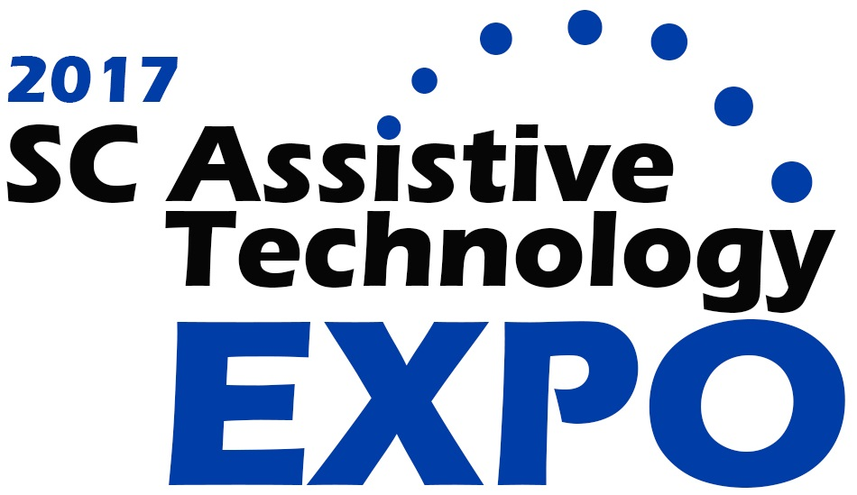

**Wednesday, March 22, 2017**

**8:30 a.m. to 3:30 p.m.**

**Columbia Metropolitan Convention Center**

**1101 Lincoln Street, Columbia, SC 29201**

**Free Admission and Open to the Public**

**Accessible parking at convention center and in parking garage**

**at the corner of Lincoln and Pendleton Streets**

**Exhibits and Workshops showcasing Assistive Technology**

**for people of all ages**

For special accommodations, contact SCATP at 1-800-915-4522 or

803-935-5263 or email Lydia.durham@uscmed.sc.edu.

The 2017 SC Assistive Technology Expo is sponsored by the SC Assistive Technology Program, Center for Disability Resources, USC School of Medicine, USC School of Medicine Department of Pediatrics, SC Department of Education, SC Developmental Disabilities Council, and Mid-Carolina Area Health Education Consortium.  For more information, go to scatp.med.sc.edu/expo/expo17.html

# Assistive Technology Expo 2017 Session Schedule

**Session 1 - 9:00 am to 10:00 am**

**Access to Technology for ALL Students 1** Explore ways Special Services and Instructional Technology partner to ensure every student has access to assistive technology. Angie Slatton, BA, MAT, EdS, PhD, Dir. of Special Services, Lisa Knoche, BA, MA, Digital Integration Specialist, Lex/Rich School District 5

**AAC and Literacy 1, 2, 3** Learn best practices and strategies for promoting literacy through the use of augmentative and alternative communication systems at school and at home. Video examples will be shared. Jeanette Cox, BA, MS, Speech Language Pathologist, Aiken County School District

**How to Make and Use Accessible Documents 1** “How to” session for making all of your documents accessible in MS Word, Google or PDF. Accessible documents allow people with disabilities access to the written word. Free resources will be shared.

Carol Page, PhD, CCC-SLP, ATP, CBIS, Program Director, SC Assistive Technology Program

**Adaptive Sports Overview 1** Learn the history and evolution of adaptive sports, with a focus on cycling, water skiing, alpine skiing, sled hockey, and golf. Experience hands-on use of adaptive equipment, including the Stand Up and Play Paramobile (a specialized wheelchair that supports an individual in a standing position).

Kristen Caldwell, MS, CTRS, Supervisor of Recreation Therapy, Danielle Fitzmorris, MSM, CTRS, Supervisor of Recreation Therapy, Roger C. Peace Rehabilitation Hospital

**Session 2 - 11:00 am to Noon**

**Counting on Workers with Disabilities Panel Discussion 1** Learn from a panel of Human Resource professionals the tangible benefits and tax benefits for hiring workers with disabilities. Accessibility solutions continue to be useful and expand to be more mainstream.

Gayel Wigfall, BA, GCDF, HCS, Diversity/ Human Capital Consultant, BCBS of SC

Larry Kraemer, MBA, Area Human Resource Manager, Walgreens Distribution Center

Andrea Kaelin, MSHRM, BA, MS, System Director of Human Resources, Palmetto Health

**AAC Evaluation Framework for Success 1, 2, 3**Learn 3 major components of successful augmentative and alternative communication use including the evaluation, guidelines for tailoring the evaluation process, and 3 frameworks that can be used to describe the communication competencies of individuals with complex communication needs. Celeste Helling, MA, CCC-SLP, ATP, Speech-Language Pathologist, Lauren Zubow, MA, CCC-SLP, ATP, Speech Language Pathologist, NC Assistive Technology Program

**Accessibility for Google Drive: A Closer Look at Add-ons 1** Review built-in features and Add-ons in Google Docs that can be used as assistive technology supports for reading, writing, math, organization and more. Free resources will be shared.

Madalina Tudora, BA, MA, ATP, Assistive Technology Specialist, SC Department of Education

**Living in Your Own Home with Assistive Technology 1** Review how The Supported Community Living Initiative helps individuals with disabilities live fully inclusive lives in the community using AT. Real life success stories will be shared during this session. Kristi Hartwell, MSW, CBIS, Program Coordinator, USC School of Medicine

**Session 3 – 1:30 pm to 2:30 pm**

**Assistance Dogs Panel Discussion 1, 3** Learn from a panel of professionals about the difference between an assistance dog and a therapy dog. Hear how they are trained and used to help people with disabilities.

Kristin Hartness, Executive Director, Canines for Disabled Kids, Jennifer Rogers, Executive Director, PAALS, Phyllis Beasley, Owner and Lead Trainer, Praise Dog Training, LLC

**AAC Funding in the Schools and Community 1, 2, 3** Learn to simplify the process for augmentative and alternative funding requests for all ages. Learn what the AAC letter of medical necessity for Medicaid or Medicare includes. Review school AAC purchases. AAC report and letter templates will be shared.

Sharon Steed, M.Ed, CCC-SLP, Speech-Language Pathologist, AnMed Health

**AT Opportunities for the Transition Age Student 1** Explore potential benefits of AT and how it impacts the ability of a student to compete in the classroom and the community. Look at various AT tools that help to level the playing field in the classroom for transition-age students heading to work or college. Mark Daniels, M.Ed, Assistive Technology Specialist, SC Department of Education

**Voice Controlled Assistive Technology Solutions 1, 3** Learn how voice-controlled AT solutions are viable for individuals with disabilities. Demonstrations of how the Amazon Echo, Google Home, Okay Google and Hey Siri devices can help with daily living, environmental control and lifestyle enhancements for individuals with physical, sensory and cognitive disabilities.

Darrell Owens, Program Assistant, SC Assistive Technology Program, Alecia Reagan, Sales Assoc., ABC Medical 1CEU credits have been applied for by AHEC for the disciplines: Nursing, Social Work and Physical Therapists.

2CEU credits have been applied for from ASHA for speech-language pathologists. .

3 3 CEU credits have been approved by BabyNet.

It is the responsibility of each participant to ensure that the CEU credit awarded for the purpose of licensure or certification renewal meets the specific criteria and complies with his/her relevant prof. statutes, policies, and regulations at the time of the offered sessions. 12/12/16