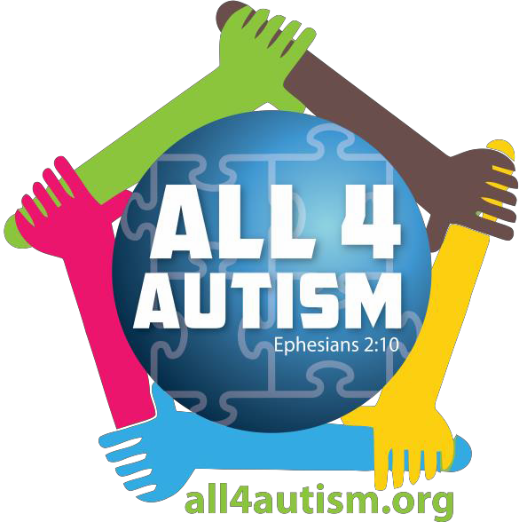ALL 4 AUTISM
SUMMER WORKSHOPS

All 4 Autism invites you to our Summer Workshop Series.
Workshops presented by Family Connection
of South Carolina
These workshops are free to the public, and cover a variety of topics:

Navigating Special Education: June 13, 2017 (6:00-8:00 PM)
Medicaid 101-Understanding TEFRA: June 21, 2017 (12:30-2:30 PM)
Positive Parenting for Children with Disabilities: June 22, 2017 (6:00-8:00 PM)
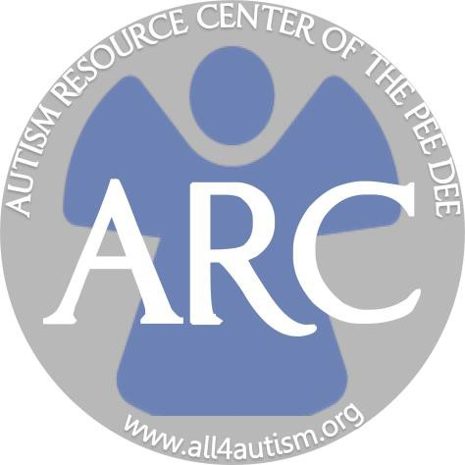Helping Your Children Reach Their Full Potential: July 13, 2017 (6:00-8:00 PM)

FOR MORE INFORMATION:
www.all4autism.org

TO REGISTER:
https://fs27.formsite.com/all4autism/form11/index.html

