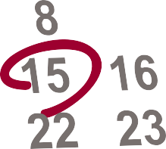OPEN ENROLLMENT IS FROM

NOVEMBER 1 – DECEMBER 15!

Of health plans purchased through the marketplace in South Carolina, 9 out of 10 qualified for discounts on monthly premiums.

Visit www.SignUpSC.org or call
888.998.4646 for questions or to sign up.

