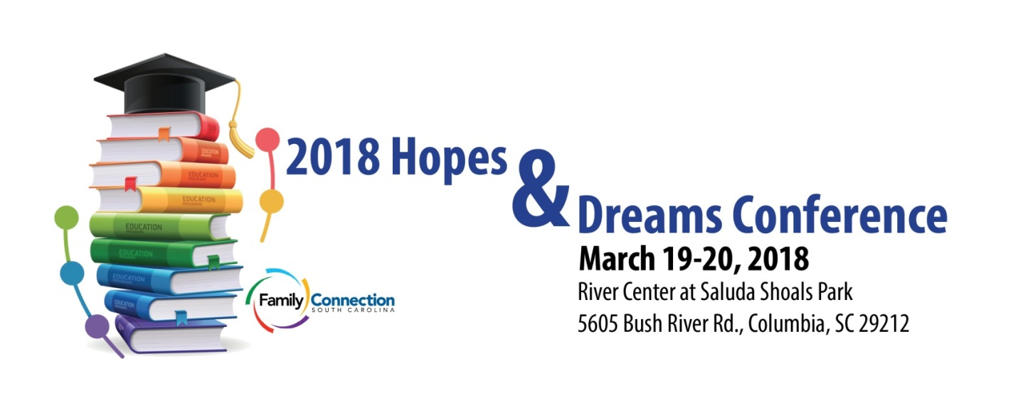
CONFERENCE WORKSHOPS
Monday March 19, 2018
Breakout 1 11:30 am – 12:45 pm
- SC Hands & Voices: Parent- Driven Support for Families with Children who are D/HH - Jocelyn Ross and Marcella Forrest
- Pediatric Feeding Disorders in Infants and Toddlers - Sally Asquith, MS, CCC-SLP
- “When the IEP Team Says No….Options for Dispute Resolution” - Amanda Hess, Esq
- Supported Decision Making and Alternatives to Guardianship in SC - Charlie Walters, BA, MAT and Sarah St. Onge, BA, JD
- Exploring the new SC Employability Credential: What families should know - Tabitha Strickland, Joy Godshall Ivester, MEd, BA, Amy A. (Nienhuis) Holbert, LISW-CP, MSW

Breakout 2 1:45 pm – 3:00 pm
- Disability or Culture? Considerations and Implications for Children who are Deaf or Hard of Hearing - Maureen Irons, Ed.D
- Therapeutic Touch: Reaching Out to Those with Tactile Aversion - Elizabeth Geiger Harvey, DPT, MSR, CKTI, CEIM
- Risk and Protective Factors for Families of a Child with ASD - Kate K. Chappell, MSN, APRN, CPNP-PC and Amy Moseley, MA
- Ending the Silence for Families - Betsey O'Brien and Deniece Chi
- Successful Transitions: Building Pathways to Employment - Jennifer Bazer and Casey Eubanks

Breakout 3 3:15 pm – 4:30 pm
- Language & Connection – How Language Impacts Social Development - Mary Reaves, MRC
- Preschool Initiatives and Inspiration from Families and the Field! - Jenny May MEd, PhD.
- The Impact of Specialized Early Intervention Services for Young Children with a Visual Impairment - Jodi Floyd, M.S. ed, NBPTS
- Ending the Silence for Professionals - Betsey O'Brien and Deniece Chi
- Building protective factors and preventing adverse childhood experiences (ACEs) in schools and communities- Allison E. Farrell, MPH, LISW-CP, ACM and Birley Wright, M.Ed.
Tuesday March 20, 2018
Breakout 1 11:00 am – 12:15 pm
- Getting to the Heart of the IEP for Deaf and Hard of Hearing Children - Mariann Carter , M.S, M.Ed., EIPA 3.9, NBCT- Retired and Kandice Hunt , B.A., AV. Ed. LSLS Candidate
- Chasing The Swallow - Michelle Dawson, MS, CCC-SLP
- South Carolina Early Learning Standards for Children Birth - 5 years old - Noelle P McInerney, BS, MEd; doctoral candidate (PhD in ECE)
- Finding Child Care: Tips and Resources - Carrie Trivedi, MAT
- Working with Latino Families of Children with Intellectual and Developmental Disabilities - Sandy Magaña, PhD, MSW

Breakout 2 1:15 pm – 2:30 pm
- The South Carolina Deaf-Blind Project 101 - Marcy Meachum, TVI and Krista Olsen, TVI
- Language, Construction Paper, and Ice Cream Sandwiches: Making Learning Happen - Cara Senterfeit, B.S., NBCT and Minnie Lambert
- Understanding the IEP - Melissa Sanders BS; MBA and Yury Cardona
- What is Special Population, and how can we support the needs of this unique population of students? - Sara Garrett, M.Ed
- Why Do I Need a "Medical Home" - Kim Conant, LPN

Breakout 3 2:45 pm – 4:00 pm
- AAC Interventions for Children - Carol Page, PHD, CCC-SLP, ATP, CBIS
- School to Work Transition help beyond the School—VR, Employers & CAP - Pete Cantrell, Attorney at Law
- Parent Partnerships for Preschool Inclusion - Kerri Kannengieser, MS Ed. And Amy A. (Nienhuis) Holbert, LISW-CP
- Medicaid 101 - The Basics of Medicaid and TEFRA - Shannon Staley, MSW, Beverly Harper, Abby Rivera
- Exceptional SC Special Needs program and where it stands – Chad Connelly, Exceptional SC

