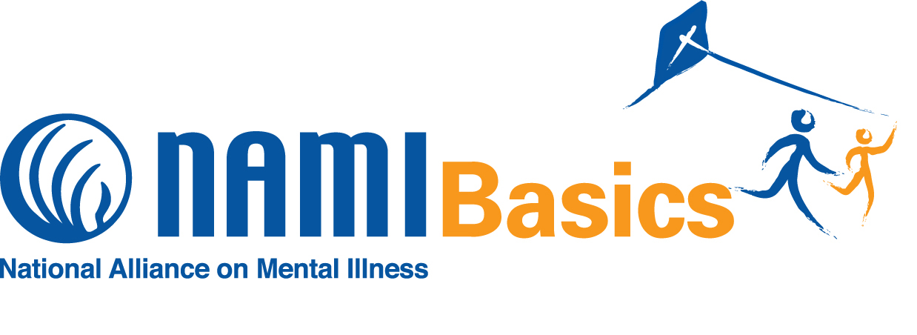
FREE 15 Hour Education Course

For Parents of Children and Adolescents with

Behavioral and Emotional Challenges

NAMI Basics is a six-session program designed for parents and other family caregivers of children and adolescents with emotional and behavioral difficulties. The program taught by trained teachers who are also the
Parents or family caregivers of individuals who experienced
Emotional or behavioral difficulties.

Know the facts: Find help and resources; Feel understood and validated; Develop better parenting and communication skills with your child or adolescent; Learn to work with the systems involved with your child and the importance of record keeping; Become an advocate for your child;
Know the value of self-care!

A free binder with course materials for each participant!
Pre-registration is required. Call Deniece Chi (803) 261-0516 deniece.chi@namisc.org

When: September. 17th thru October. 29th
SKIPPING OCTOBER 8th ( COLUMBUS DAY)
6:00 pm – 8:30 pm
(6 Consecutive Monday evenings)

Where: 1800 St. Julian Place, Suite 104 Columbia, SC 29204

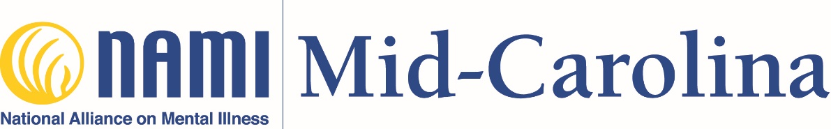

NAMIMID-CAROLINA.ORG

