What is Partners?

Partners in Policymaking® is an innovative leadership program created specifically to teach people with disabilities and the parents of young children with disabilities to:
- Become agents of long-term change.
- Be active partners with the policymakers whose decisions will shape their future.
- Dream about a future with possibilities.

Focus Areas

- Parliamentary Procedure
- Assistive Technology
- Education
- Making Your Case
- Employment
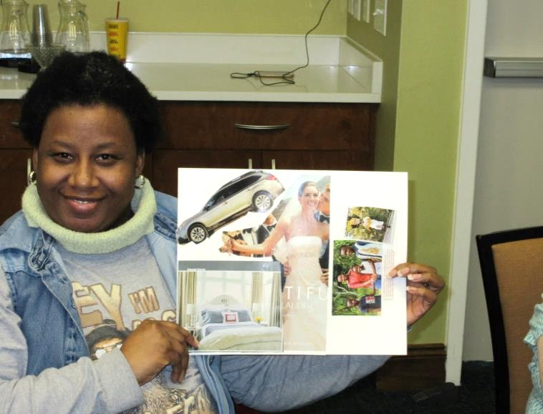

Cost

- There is no financial cost for any of the sessions.

- Participants are reimbursed for their travel to and from Columbia.

- Lodging and meals are provided. Participants receive dinner Friday and breakfast and lunch Saturday.

- Attendant care and respite services are reimbursed when necessary.

- Other reasonable accommodations are provided at no cost to the participant.

- Program materials are provided at no cost.

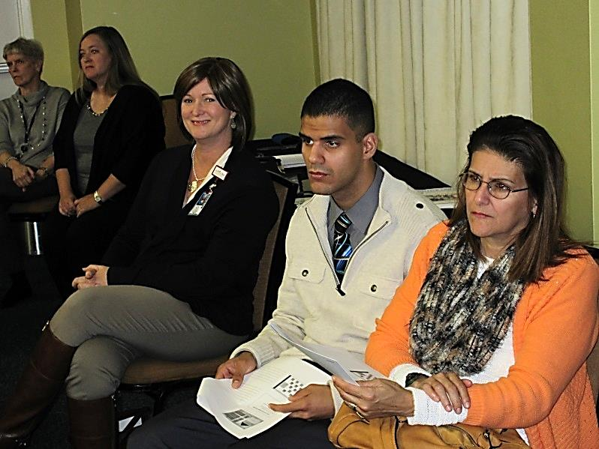

Expectations

Participants in the Partners in Policymaking® program are expected to attend five two-day sessions between October and March. All sessions begin at 12:00 p.m. on Friday and conclude by 4:30 p.m. on Saturday. By building skills to advocate with elected officials and other policymakers, partners directly impact people with disabilities and their families. Participants will have a better chance of influencing changes to existing policies or development of new policies.

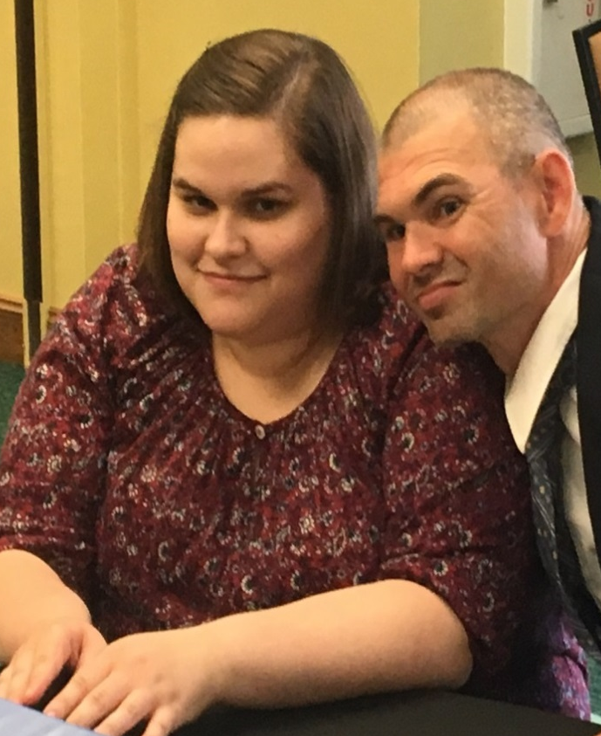

Priorities Area
Session 1
- Introduction
- Disability History

Session 2
  - Inclusive Education
  - Transition
  - Supported/Competitive Employment

Session 3
  - Local Government
  - Community Organizing
  - Service Coordination/Case
  - Management
  - Vision

Session 4
  - Assistive Technology
  - Supported Living/Independent Living
  - State House Visit
  - State Legislation
  - Federal Legislation

Session 5
  - Parliamentary Procedure and Serving on Boards
  - Graduation

PURPOSE

The South Carolina Developmental Disabilities Council was established in 1971 by Executive Order of the Governor and was last reauthorized in 2015. Not less than 60% of the total Council membership is consumers and family members. Additional membership comes from state agencies, DD Act partners and non-governmental organizations.
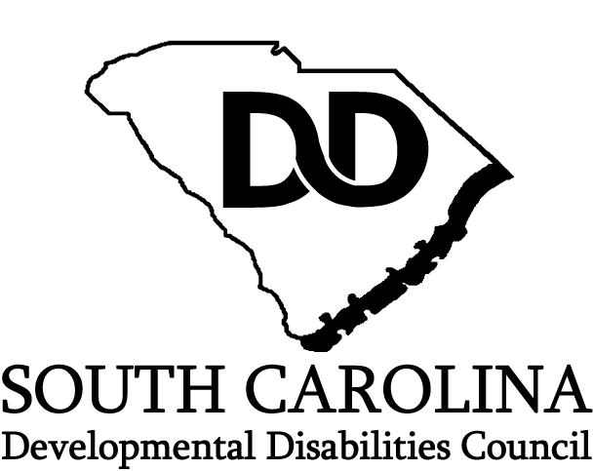

1205 Pendleton Street
Columbia, SC 29201
(803) 734-4190
Fax (803) 734-0241
scddc.sc.gov

This brochure was funded in part by grant
#1801SCBSDD of the Administration Community Living

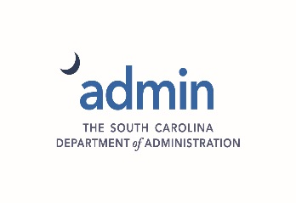

SOUTH CAROLINA DEVELOPMENTAL DISABILITIES COUNCIL
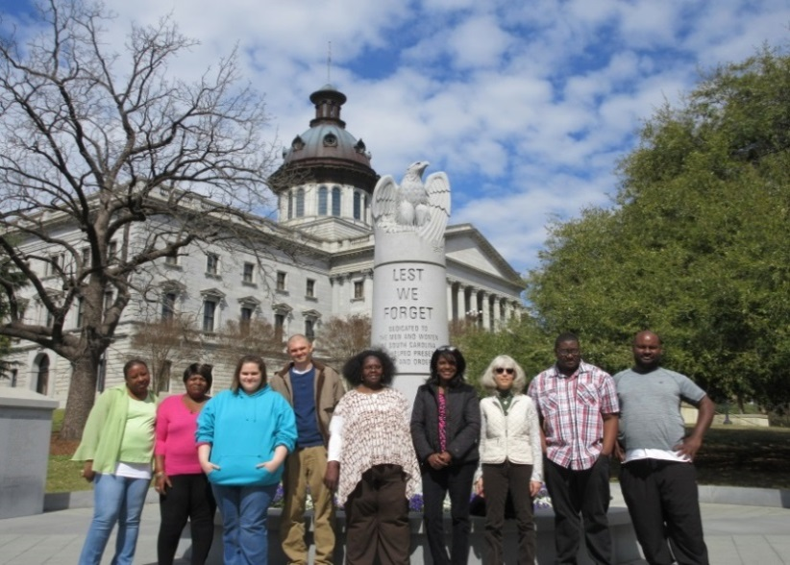
PARTNERS IN POLICYMAKING®

Partners in Policymaking® is a leadership training program which teaches self-advocates and parents how to be community leaders and how to obtain the best available services for themselves and others. The Minnesota Governor’s Council on Developmental Disabilities introduced the Partners in Policymaking program in 1987, and, through expansion to other states and countries, has trained more than 27,000 people worldwide. Participants travel to Columbia once a month for five months. Participants receive information, training and resources about local, state and national issues that affect people with disabilities.

