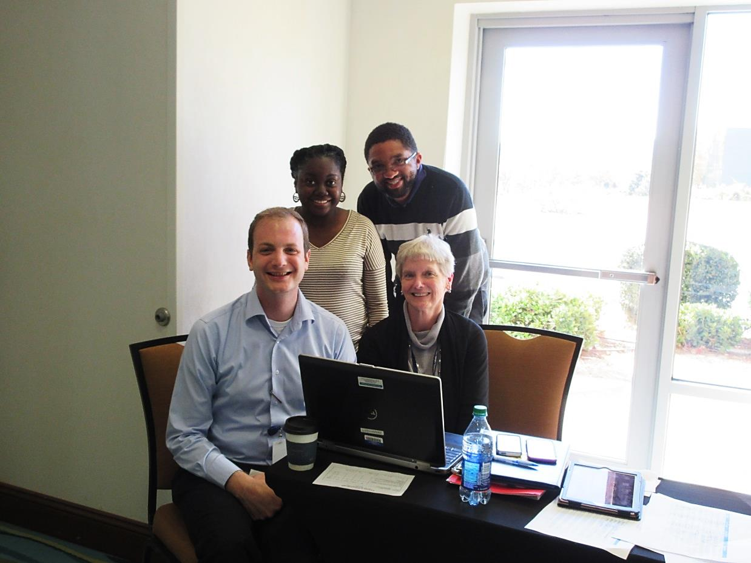

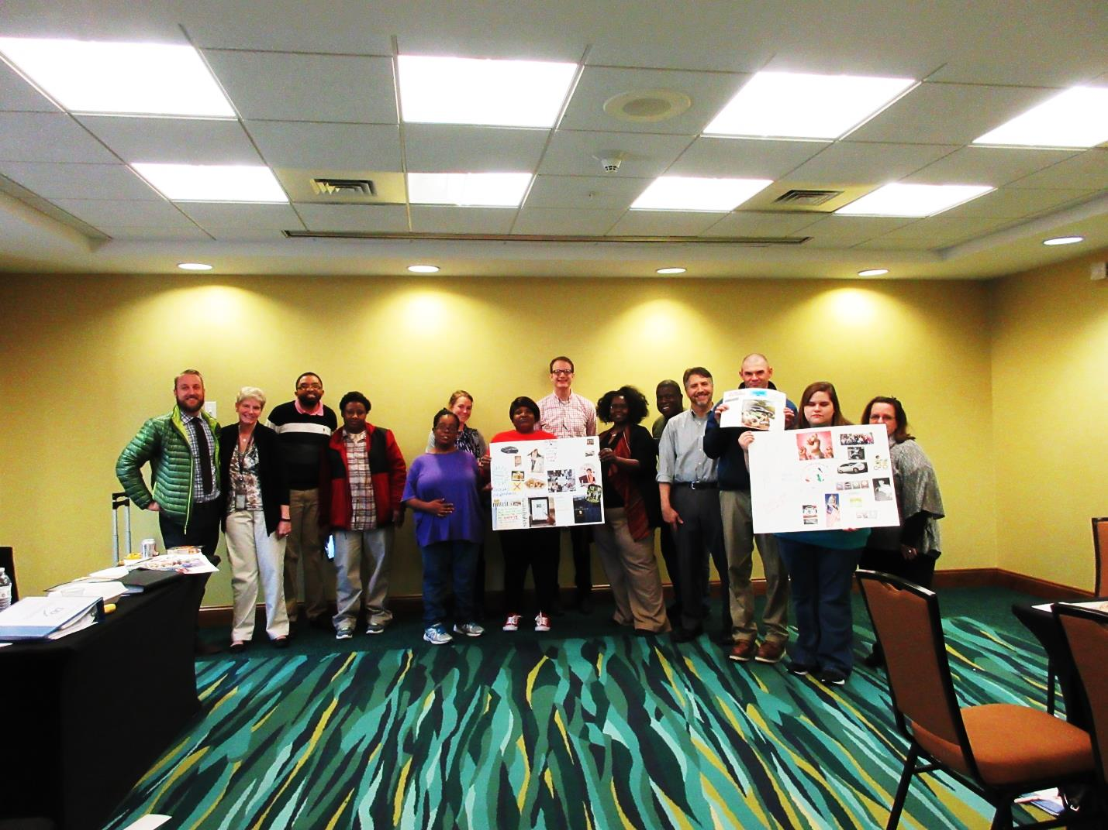

**Partners in Policymaking® Program**

**October 19th -March 9th**

**Location: SpringHill Suites, Columbia SC**

**This is program is only for young adults with intellectual and developmental disabilities and parents with young children with intellectual and developmental disabilities.**

**Now Accepting Applications**

[**www.scddc.sc.gov**](http://www.scddc.sc.gov)

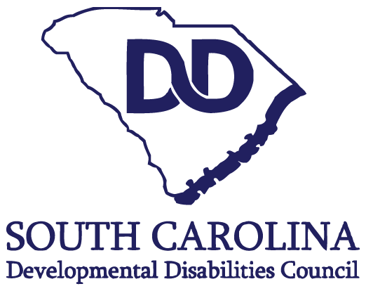**Sponsored by:**