Autism Consortium for Parents 2018-2019
REGISTRATION FORM
Name: ____________________________________________________________
Child’s Age: _______________________________________________________
Email: ____________________________________________________________

Which session will you attend? Please choose:

September 25th October 30th November 27Th January 29th

February 26th March 26th

Please email the registration form to Kylie McKinney

kbmckinney@spart7.org
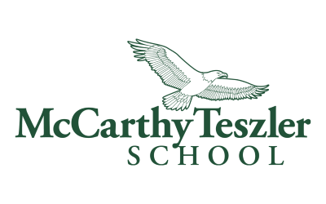

McCarthy Teszler School (District 7) and Family Connection of SC 2018-2019
Dear Parent(s)/ Caregiver(s) of a child/children with Autism,
You are invited to participate in the Autism Consortium for Parents 2018-2019, hosted by McCarthy Teszler School (District 7) and Family Connection. Sessions will be held from 5:00 pm-6:00 pm on Tuesdays (last Tuesday of every month) the dates listed below.
249 North Grove Medical Park Drive
2nd Floor
Spartanburg, SC 29303
We will discuss latest research on autism and practical solutions for you to use on a daily basis.
Schedule for Parents:
September 25th (Tuesday) from 5:00-6:00

Autism, who it Affects, and the Types
October 30th (Tuesday) from 5:00-6:00

Autism vs. Learning and Attention Issues: What You Need to Know
November 27th (Tuesday) from 5:00-6:00
*Questions will be submitted prior to the session via questionnaire/form
Question and Answer Forum
January 29th (Tuesday) from 5:00-6:00
Autism Strength and Abilities
February 26nd (Tuesday) from 5:00-6:00
Challenging Behaviors and Social Issues
March 26th (Tuesday) from 5:00-6:00
*Questions will be submitted prior to the session via questionnaire/form
Question and Answer Forum

